4.3 Launch an Instance in a Placement Group

**Step 4.3.1:** Creating a placement group

* Click on *Create Placement Group*

# 

* Provide a name and strategy

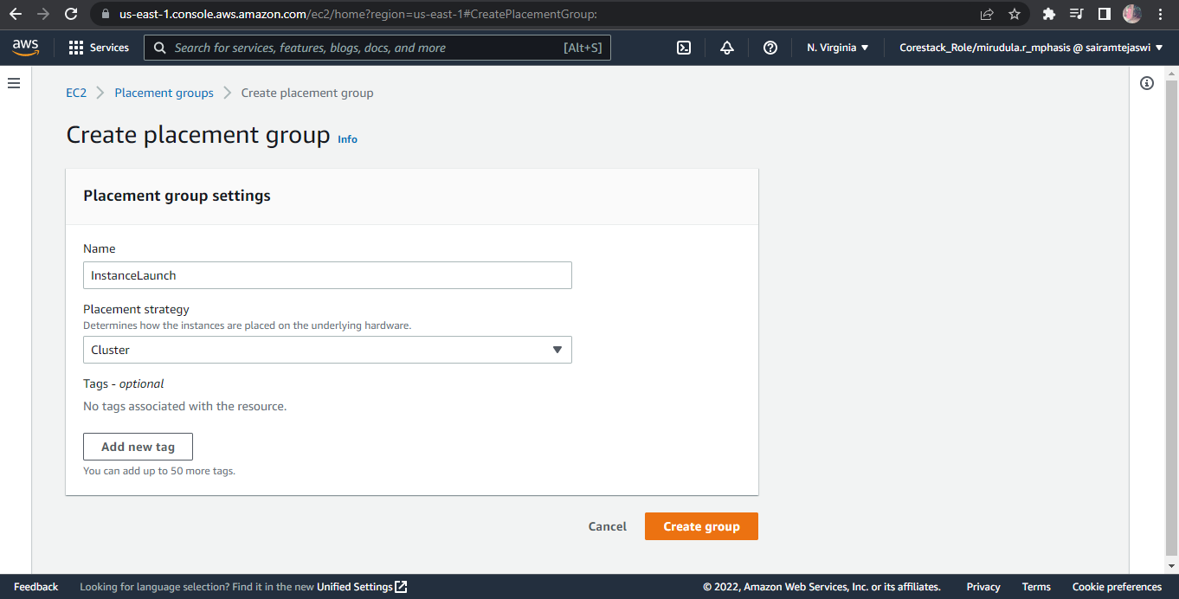

**Step 4.3.2:** Launching an instance in the placement group

* Launch the new EC2 instance

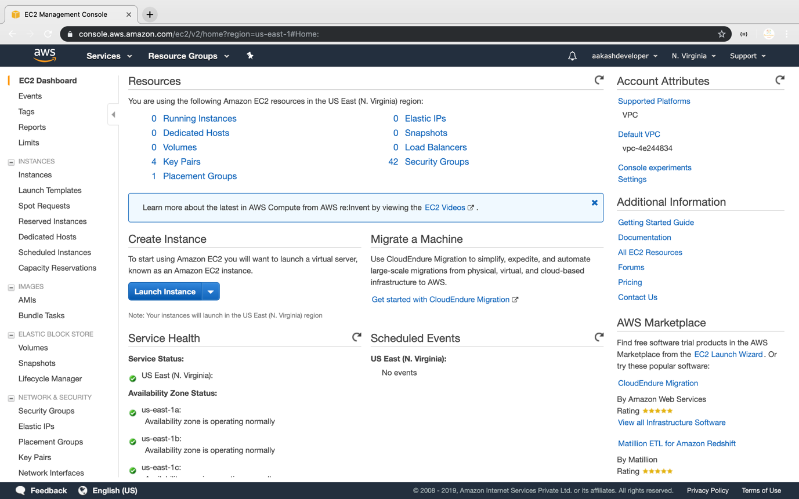

* Select the placement group

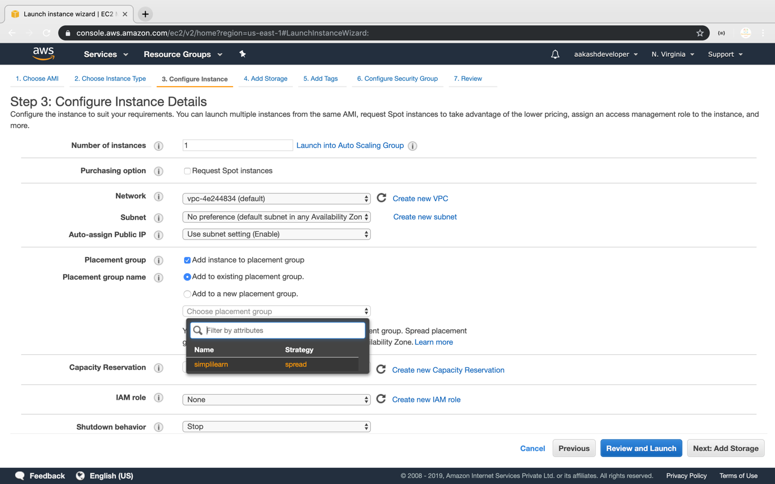

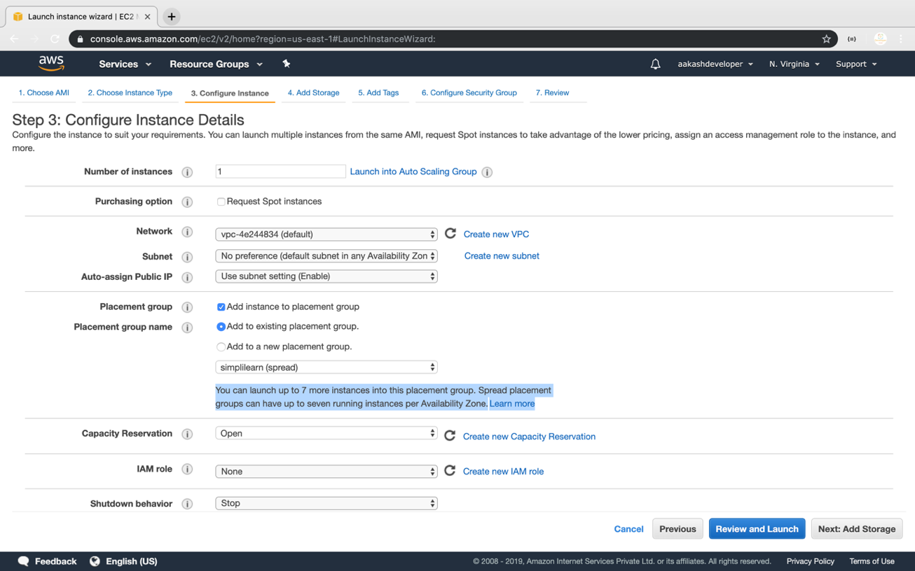

* Verify the placement group of the instance

